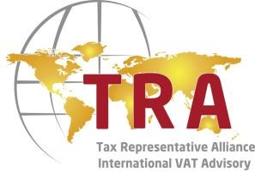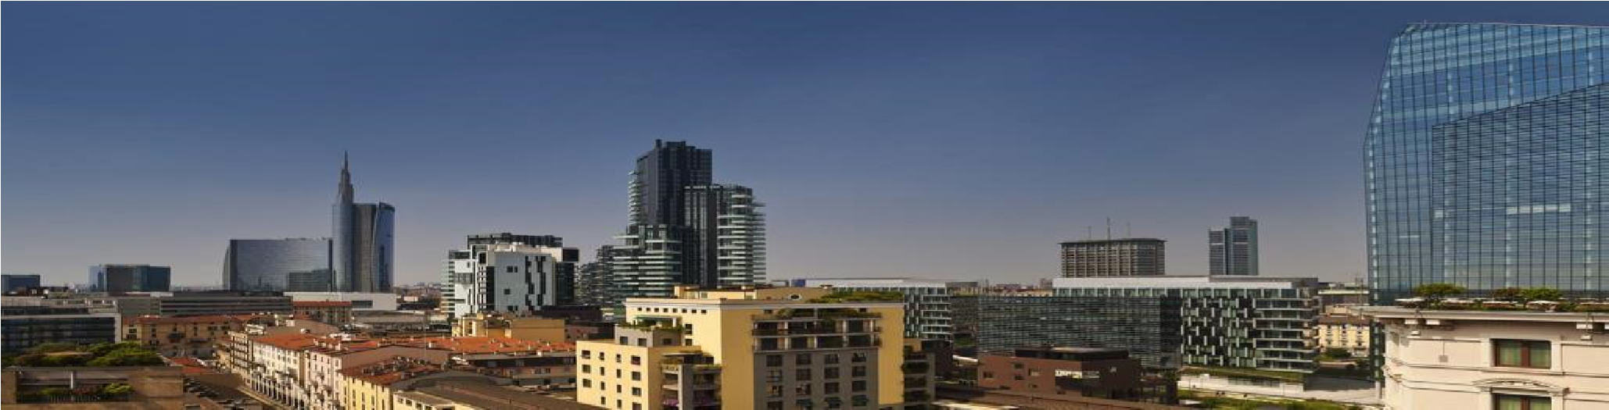
ITALIAN VAT SYSTEM

Dear Sir / Madam,

We are pleased to invite you to the free half
-
day conference organized by the Tax Representative Alliance

(
TRA),
the European network of VAT specialists covering 20 countries,

on Thursday 11th May 2017, at 02:00 pm
at the Hotel Me Milan II Duca Piazza della Repubblica n.13
20124 Milan
This conference is a unique opportunity to meet up with VAT specialists who may give you useful advise if you plan to develop your business in Italy or in other EU countries and/or you have faced difficulties in dealing with VAT issues or in case you need information on the services offered by our alliance, besides the services already rendered.
The agenda of this conference is the following :
14:00 – 14:15 : Welcome coffee
14:15 – 15:45 : Conference
14:15 – 14:45 “Doing Business in Italy: principal direct and indirect taxes. Focus on Value-Added Tax” - Mr. Corrado Cassinis
14:45 – 15:15 “Italian VAT system: the recent legislative modifications” – Mrs. Beatrice Masserini
15:15 – 15:45 “Hungarian VAT system” Mrs. Lilla Stricca
15:45 – 16:00 : Coffee break
16:00 – 18:00 : B2B meetings with TRA members
18:00 – 19:00 : Cocktail

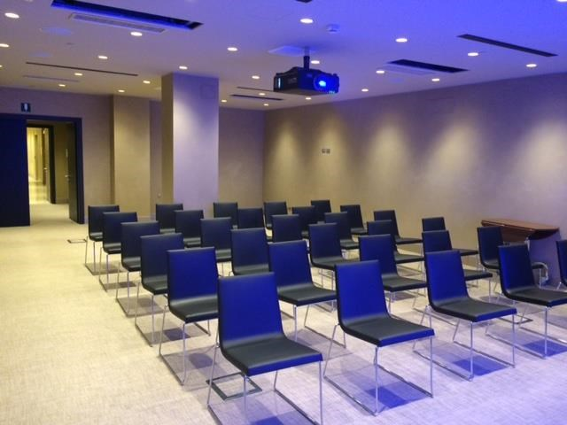
This conference will allow us to meet each other and if needed, to make a briefing on your own file.
You may also attend one-to-one meetings with the TRA members.
Please answer the questions below:
Would you like to meet up with us ? □ yes □ no Would you like to have meetings with other TRA members ?
□ yes, with the following countries : ………….………….………….
□ no
Please return back this invitation before the 15th April 2017 to the following email address: .................

